Computer Programming  
Lab Tasks



Department of Computer Science - BUIC

Name: Saad Ahmad

Enrollment Number: 01-134222-130

**Exercises/Lab Journal 10**

**Task 0:** Write the two ways of displaying the 4th element of an array **num** of type **float** and size **10.**

|  |  |
| --- | --- |
| **using array subscript notation:** | float num[10] = { 1,2,3,4,5,6,7,8,9,10 };  cout << "num[3] = " << num[3]; |
| **using array offset notation:** | float num[10] = { 1,2,3,4,5,6,7,8,9,10 };  float *numPtr = num;  cout << "*(numPtr + 3) = " << *(numPtr + 3); |

**Task 1: Assume the definitions and initializations:**

char c = 'T', d = 'S';

char *p1 = &c;

char *p2 = &d;

char *p3;

Assume further that the address of c is 6940, the address of d is 9772, and the address of e is 2224. What will be printed when the following statements are executed sequentially?

p3 = &d;

cout << "*p3 = " << *p3 << endl; // (1)

p3 = p1;

cout << "*p3 = " << *p3 // (2)

<< ", p3 = " << p3 << endl; // (3)

*p1 = *p2;

cout << "*p1 = " << *p1 // (4)

<< ", p1 = " << p1 << endl; // (5)

**Output :**

*p3=S

*p3=T,p3=6940

*p1=S,p1=6940

1. Consider the following statements:

int *p;

int i;

int k;

i = 42;

k = i;

p = &i;

After these statements, which of the following statements will change the value of i to 75?

A. k = 75;

B. *k = 75;

C. p = 75;

D. *p = 75;

E. Two or more of the answers will change i to 75.

**Ans:** Option D

1. Explain the error.

char c = 'A';

double *p = &c;

**Ans:** We created a variable c with a char data type so its pointer has to be of the same data type so the data type of the pointer cannot be double it has to be char.

**Task 2**: Introduce **int** variables **x** and **y** and **int\*** pointer variables **p** and **q**. Set **x** to 2, **y** to 8, **p**

to the address of **x**, and **q** to the address of **y**. Then print the following information:

1. The address of **x** and the value of **x**.
2. The value of **p** and the value of **\*p**.
3. The address of **y** and the value of **y**.
4. The value of **q** and the value of **\*q**.
5. The address of **p** (not its contents!).
6. The address of **q** (not its contents!).

#include <iostream>

using namespace std;

int main(){

int x, y;

int* p, * q;

x = 2;

y = 8;

p = &x;

q = &y;

cout << "Address of x:" << p << ", x=" << x << endl;

cout << "\np= " << p << ", *p= " << *p << endl;

cout << "\nAddress of y:" << q << ", y=" << y << endl;

cout << "\nq= " << q << ", *q= " << *q << endl;

cout << "\nAddress of p:" << &p << endl;

cout << "\nAddress of q:" << &q << endl;

return 0;

}

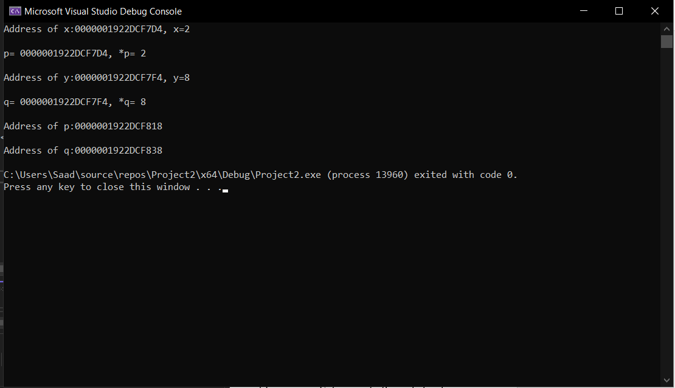

**Task 3**: Introduce **int** variables **x**, **y**, **z** and **int\*** pointer variables **p**, **q**, **r**. Set **x**, **y**, **z** to three distinct values. Set **p**, **q**, **r** to the addresses of **x**, **y**, **z** respectively.

1. Print with labels the values of **x**, **y**, **z**, **p**, **q**, **r**, **\*p**, **\*q**, **\*r**.
2. Print the message: Swapping values.
3. Execute the swap code: **z = x; x = y; y = z;**
4. Print with labels the values of **x**, **y**, **z**, **p**, **q**, **r**, **\*p**, **\*q**, **\*r**.

#include <iostream>

using namespace std;

int swap(int &a, int &b, int &c);

int main(){

int x, y,z;

int* p, * q ,*r;

x = 10;

y = 20;

z = 30;

p = &x;

q = &y;

r = &z;

cout << "x=" << x << ", y=" << y << ", z=" << z << endl;

cout << "p=" << p << ", q=" << q << ", r=" << r << endl;

cout << "*p=" << *p << ", *q=" << *q << ", *r=" << *r << endl;

cout << "Swapping values" << endl;

swap(x, y, z);

cout << "x=" << x << ", y=" << y << ", z=" << z << endl;

cout << "p=" << p << ", q=" << q << ", r=" << r << endl;

cout << "*p=" << *p << ", *q=" << *q << ", *r=" << *r << endl;

return 0;

}

int swap(int &a, int &b, int &c) {

int temp;

temp = c; // temp =z;

c = a; // z=x

a = b; // x=y

b = temp; // y=z

return 0;

}

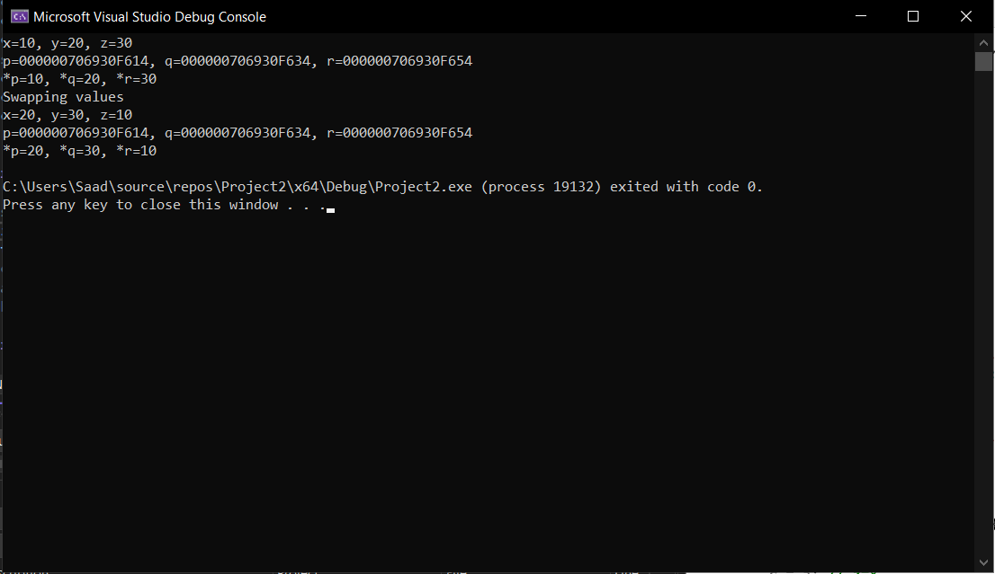

**Task 4**: Give the value of the left-hand side variable in each assignment statement. Assume the lines are executed sequentially. Assume the address of the blocks array is 4434.

int main()

{

char blocks[3] = {'A','B','C'};

char *ptr = &blocks[0];

//4434

char temp;

temp = blocks[0];

//A

temp = *(blocks + 2);

//C

temp = *(ptr + 1);

//B

temp = *ptr;

//A

ptr = blocks + 1;

//4438

temp = *ptr;

//B

temp = *(ptr + 1);

//C

ptr = blocks;

//A

temp = *++ptr;

//B

temp = ++*ptr;

//C

temp = *ptr++;

//C

temp = *ptr;

//C

return 0;

}

Output :

4434

A

C

B

A

4438

B

C

A

B

C

C

C

**Task 5:** Write the output

int main ()

{

int numbers[5];

int * p;

p = numbers;

*p = 10; p++;

*p = 20;

p = &numbers[2];

*p = 30;

p = numbers + 3;

*p = 40;

p = numbers;

*(p+4) = 50;

for (int n=0; n<5; n++)

cout << numbers[n] << ", ";

return 0;

Output :

10, 20, 30, 40, 50